

# ANTI-BULLYING POLICY

**Ratified by the Board of Management: 2013**

**Signed: 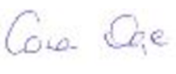 (Co-ordinators)**

**Signed: C:\Users\Conan Daye\Documents\Staff SnaCM\Niall's Signature.JPG (Chairperson B.O.M.)**

**Date: Last reviewed: 8th of April 2019**

**For review: 2022**

Scoil na Coróine Mhuire

ANTI-BULLYING POLICY

Created: 2013

Last reviewed: 8th of April 2019

Next Review: 2022

[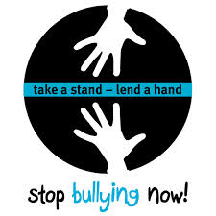](http://scoiltalbot.scoilnet.ie/blog/files/2013/10/take-a-stand-lend-a-hand-stop-bullying-now.jpg)

1. **Full Compliance**

In accordance with the requirements of the Education (Welfare) Act 2000 and the code of behaviour guidelines issued by the NEWB, the Board of Management of Scoil na Coróine Mhuire National School has adopted the following anti-bullying policy within the framework of the school’s overall code of behaviour.

2. **Key Principles of Best Practice**

The Board of Management recognises the very serious nature of bullying and the negative impact that it can have on the lives of pupils and is therefore fully committed to the following key principles of best practice in preventing and tackling bullying behaviour:

* A positive school culture and climate which:
* is welcoming of difference and diversity and is based on inclusivity;
* encourages pupils to disclose and discuss incidents of bullying behaviour in a non-threatening environment;
* promotes respectful relationships across the school community;
* Effective leadership;
* A school-wide approach; Individual Behaviour Plans managed by sub-teams of Principal, Teacher, SET, SNA and any other staff who work closely with the child
* A shared understanding of what bullying is and its impact;
* Implementation of education and prevention strategies (including awareness raising measures) that:
* build empathy, respect and resilience in pupils; and
* Explicitly address the issues of cyber bullying and identity‑based bullying, homophobic and transphobic bullying.
* Effective supervision and monitoring of pupils;
* Supports for staff;
* Consistent recording, investigation and follow up of bullying behaviour (including use of established intervention strategies)
* On-going evaluation of the effectiveness of the anti-bullying policy.

3. **The Definition of Bullying**

In accordance with the Anti-Bullying Procedures for Primary and Post‑Primary Schools, bullying is defined as follows:

***Bullying is unwanted negative behaviour, verbal, psychological or physical conducted, by an individual or group against another person (or persons) and which is repeated over time.***

The following types of bullying behaviour are included in the definition of bullying:

* deliberate exclusion, malicious gossip and other forms of relational bullying, extortion, isolation, and persistent name calling,
* cyber bullying, and
* Identity-based bullying such as racist bullying, bullying based on a person’s membership of any specific community, and bullying of those with disabilities or special educational needs.

Isolated or once-off incidents of intentional negative behaviour do not fall within the definition of bullying and should be dealt with, as appropriate, in accordance with the school’s code of behaviour.

However, in the context of this policy, placing a once-off offensive or hurtful public message, image or statement on a social network site or other public forum where that message, image or statement can be viewed and/or repeated by other people will be regarded as bullying

behaviour.

Negative behaviour that does not meet this definition of bullying will be dealt with in accordance with our school’s code of behaviour.

Additional information on different types of bullying is set out in Section 2 of the Anti-Bullying Procedures for Primary and Post-Primary Schools.

This policy applies to activities and events that take place:

* During school time (including break times)
* Going to and from school
* School tours/trips
* Extra-curricular activities

Scoil na Coróine Mhuire reserves the right to take action against bullying perpetrated outside the school which spills over into the school.

**Bullying by Adults**

In the case of **intra-staff bullying**, Scoil na Coróine Mhuire N.S. will adopt the procedures outlined in Section C (c2) of the INTO booklet, ‘Working Together: Procedures and Policies for Positive Staff Relations’.

A copy of this document is available for free download on the INTO website.

In the case of **Teacher-Child bullying**, a complaint should in the first instance be raised with the teacher in question by the parent/guardian of the child if possible and then if necessary referred to the Principal.

Where it has not been possible to agree a framework for resolution, the matter should be referred in writing by both parties to the Board of Management for investigation.

In the case of **Parent-Teacher bullying**, the Principal should be informed in the first instance, and if deemed necessary the Board of Management should subsequently be informed.

In the case of **Parent/Visitor to the school – Child bullying**, the complaint should be referred in the first instance to the child’s class teacher and subsequently to the Principal if unresolved.

In the case of **Principal-Parent/Child bullying**, the matter should be raised with the Principal if possible, or referred to the Chairperson of the Board of Management.

4. **Who Is Responsible For Doing What**

The relevant teacher(s) for investigating and dealing with bullying are as follows:

**Anti-Bullying Coordinators:**

* **Conan Daye** *(School Principal)*
* **Suzanne Earls** *(Deputy Principal)*

**Those Responsible For Implementing This Policy:**

* **Yard Duty Staff**

Special Needs Assistants (SNAs) will assist teachers in monitoring pupils and activities on yard.

* **IBP Teams**
* **All Teaching Staff, with the support of SNAs**All Teaching Staff, with the support of SNAs, will investigate and record incidents of bullying behaviour.

Note: The "relevant" teacher is normally the class teacher.

**Responsibilities of Parents:**

- To support the school in the implementation of the policy.

- To watch out for signs that their child may be being bullied.

- To speak to the class teacher if their child is being bullied or they suspect that this is happening.

- To speak to the class teacher as soon as they are aware that issues are arising which are affecting their child.

- To instruct their children to tell if they are being bullied or if they have seen other pupils being bullied.

- To notify the school if they think that their child is displaying bullying behaviour and to work with the school in addressing this problem. They should not defer letting the school know of any issue, in the hope that the problem will go away.

- To ensure that if their children are online that they are using social media in a safe and responsible manner; parental supervision is very important in this area as there are risks associated with internet/website access.

- To never directly approach a student, or the parent of a student at the school to intervene in behavioural issues.

5. **Suggested Education and Prevention Strategies**

The education and prevention strategies (including strategies specifically aimed at cyber bullying) that will be used by the school are as follows:

1. Restorative Practice
2. SPHE
3. Anti-Bullying Posters
4. IPPN Anti-Bullying Campaign
5. Friends for Life Programme
6. The Incredible Years Programme
7. Stay Safe Programme & Accord
8. School Council
9. Walk Tall
10. Guest speakers from outside agencies e.g. Barnardos, Garda Community Officer
11. Webwise – Irish Internet Safety Awareness Centre, www.webwise.ie

6. **Our Procedures Re Bullying Behaviour**

The school’s procedures for investigation, follow-up and recording of bullying behaviour and the established intervention strategies used by the school for dealing with cases of bullying behaviour are as follows:

1. Since the failure to report bullying can lead to a continuation or a deterioration of bullying, the school and parents encourage children to disclose and discuss incidents of bullying behaviour. This can be with the class teacher, the teacher on yard duty at the time, Special Needs Assistants, and the principal or with parents. This is a “telling school” as defined in the Stay Safe Programme. Children will therefore be constantly assured that their reports of bullying either for themselves or peers will be treated with sensitivity.
2. An Incident of bullying behaviour will be noted and recorded by the class teacher or the teacher on duty/yard duty.
3. The Incident will be investigated – what, who, when, where, why?
4. An effort will be made to resolve any issues and to restore as far as practicable, the relationships.
5. The teacher will exercise professional judgement to determine whether bullying has occurred and as to how it can be resolved.
6. Parents and pupils are required to cooperate with any investigation.
7. Serious incidents or a recurring incident of bullying behaviour shall be reported to the principal / deputy principal.
8. If a group is involved, they will be met both individually and as a group. Each member will be asked for his/her account, written or verbal, of what happened to ensure that everyone is clear about what everyone else has said. This account will be recorded. (Restorative Practice)
9. Pupils who are not directly involved can also provide very useful information in this way, and will be expected to assist the investigation.  
   Children should understand there are no innocent bystanders if they remain passive where bullying is concerned—All bystanders *must* report bullying.
10. The alleged “bully” will be asked to reflect on his/her behaviour and its consequences for himself/herself and for the person who is the victim. (Restorative Practice) They will be reminded that the Code of Behaviour will be invoked in circumstances where it is deemed prudent. Appendix 1 may be used to record instances of bullying behaviour.
11. Parents may be made aware of this behaviour and requested to come and discuss it with the teacher/principal with a view to solving the problem. If necessary the aggressor may be asked to sign an undertaking that “this behaviour will not reoccur.”
12. The situation will continue to be monitored to ensure that the problem has been resolved. Records will be reviewed and analysed.
13. The code of behaviour will be invoked in circumstances where it is deemed prudent by the relevant teacher and school principal.
14. If the bullying behaviour continues, the matter may be referred to the school’s Board of Management. The Board will also be briefed in relation to the number, if any, of templates which have been completed.
15. In the event that a parent has exhausted the school's complaints procedures and is still not satisfied, the school must advise the parents of their right to make a complaint to the Ombudsman for Children.

7. **Cyber Bullying**

Cyber bullying includes (but is not limited to) communicating via electronic means with the objective of causing hurt, fear, embarrassment, humiliation, alarm and/or distress to one or more persons.

Cyber bullying includes the use of mobile phones and the internet with the objective of upsetting someone.

It may take the form of general insults or impersonation, defamation or prejudice‑based bullying.

*Unlike other forms of bullying a once-off posting can constitute bullying.*

While this policy addresses issues related to cyber bullying of students (i.e. situations in which one or more students are the victim[s]

of bullying), the policy also applies to teaching and other school staff.

**Key Measures re Cyber Bullying**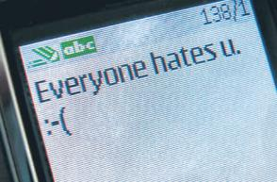

* Students will be informed about cyber bullying in the course of their education at the school.
* Gardaí will continue to visit the school once a year to talk about cyber bullying.
* Teachers will dedicate a standalone lesson to deal with the issue of cyber bullying.
* Parents will on an annual basis be invited to a talk on bullying to include cyber bullying.
* Students and staff are expected to comply with the school’s policy on the use of computers in the School. (Acceptable user policy)
* Parents and students are advised that it is illegal for a child under 13 to register with and use many social media networks, including Facebook, Instagram, and SnapChat.
* Scoil na Coróine Mhuire endeavours to block access to inappropriate web sites, using firewalls, antivirus protection and filtering systems and no pupil is allowed to work on the Internet in the Computer Room, or any other location within the school which may from time to time be used for such work, without a member of staff present.

9. **Supervision and Monitoring of Pupils**

The Board of Management confirms that appropriate supervision and monitoring policies and practices are in place to both prevent and deal with bullying behaviour and to facilitate early intervention where possible.

10. **Prevention of Harassment**

The Board of Management confirms that the school will, in accordance with its obligations under equality legislation, take all such steps that are reasonably practicable to prevent the sexual harassment of pupils or staff or the harassment of pupils or staff on any of the nine grounds specified, i.e. gender including transgender, civil status, family status, sexual orientation, religion, age, disability, race, and membership of the Traveller community.

11. **Date This Policy Was Adopted**

This policy was adopted by the Board of Management on: **Nov** 2013

Last reviewed: 8th of April 2019

Next Review: 2022

12. **Availability of This Policy**

This policy has been made available to school personnel, published on the school website and provided to the Parents Association. A copy of this policy will be made available to the Department and the patron if requested.

13. **Review of This Policy**

This policy and its implementation will be reviewed by the Board of Management once in every school year.

Written notification that the review has been completed will be made available to school personnel, published on the school website, and provided to the Parents Association.

A record of the review and its outcome will be made available, if requested, to the patron and the Department.

Signed: C:\Users\Conan\Documents\Staff SnaCM\Niall's Signature.JPG Signed: 

(Chairperson of Board of Management) (Principal)

Date: 8th of April 2019 Date: 8th of April 2019

**Appendix (1): Template for Recording Bullying Behaviour**

**1. Name of pupil being bullied and class group**

Name: ___________________________ Class: ______________________________

**2. Name(s) and class(es) of pupil(s) engaged in bullying behaviour**

|  |
| --- |
|  |
|  |
|  |

**3. Source** of bullying concern/report **4. Location** of incidents

|  |  |
| --- | --- |
| Pupil Concerned |  |
| Other Pupil |  |
| Parent |  |
| Teacher |  |
| Other |  |

Tick Relevant Box(es) (Tick relevant box)(es)

|  |  |
| --- | --- |
| Playground |  |
| Classroom |  |
| Corridor |  |
| Toilets |  |
| School Bus |  |
| Other |  |

**5. Name of person(s) who reported the bullying concern**

**6. Type of Bullying Behaviour (tick relevant box[es])\***

|  |  |  |  |
| --- | --- | --- | --- |
| Physical Aggression |  | Cyber bullying |  |
| Damage to property |  | Intimidation |  |
| Isolation / Exclusion |  | Malicious Gossip |  |
| Name Calling |  | Other (Specify) |  |

**7. Where behaviour is regarded as identity-based bullying, indicate the relevant category**

|  |  |  |  |  |
| --- | --- | --- | --- | --- |
| Homophobic | Disability /SEN related | Racist | Membership of Traveller community | Other (Specify) |
|  |  |  |  |  |

**8. Brief Description of bullying behaviour and its impact**

|  |
| --- |
|  |

**9. Details of action taken**

|  |
| --- |
|  |

**Signed: _________________________ (Relevant Teacher) Date: ___________________**

**Date Submitted to Principal/ Deputy Principal: _____________________________**

**Appendix (2): How You Can Support Your Child**

1. Support Re Cyber Bullying
2. Support Re Other Types of Bullying
3. **Support Re Cyber Bullying**

We endorse the advice given from the Irish['Sticks and Stones'](http://www.sticksandstones.ie/wp/) Anti-Bullying Programme. A representative, Patricia Kennedy, wrote the following words in the Irish Daily Mail on October 31, 2012:

"**Cyberbullying is NOT 24/7; it's only 24/7 if a child is allowed access to their phone or the internet.** Don't let your own ignorance get in the way of common sense. A simple rule is 'no phones after bedtime.' Have a drawer in the kitchen that all phones are left in.  
  
... Try turning off the wifi when you are going to bed to make sure there are no 3am online arguments. The anti-bullying initiative I represent, Sticks and Stones, work with children from all backgrounds, from designated disadvantaged schools to fee-paying schools, and **we are constantly surprised at the level of innocence that most children have in relation to the 'friends' they make online**.  
  
They don't think there are any dangers involved in chatting with strangers online, and they don't think there are any repercussions involved for them regarding what they post.  
  
... In our anti-bullying workshops, children tell us one of the reasons they don't 'tell' about bullying is that parents 'overreact'. Don't be that parent.  
  
**If your child tells you that they are being bullied** — don't lose your temper; above all don't threaten to take their phone or internet access away — you're just guaranteeing they'll never tell you anything again.  
  
Remain calm and ask questions — who, what, why, where, when. Get the facts, write it down, keep the text/phone messages or take a screen shot from the computer so you are informed when you approach the school, internet or phone provider, or gardaí.  
  
Talk to your children; let them know they can talk to you; keep the channels of communication open."

And we endorse the advice given by the USA’s Federal Department of Health:

“**Be Aware of What Your Kids are Doing Online**

Talk with your kids about cyberbullying and other online issues regularly.

Know the sites your kids visit and their online activities. Ask where they’re going, what they’re doing, and who they’re doing it with.

Tell your kids that as a responsible parent you may review their online communications if you think there is reason for concern. Installing parental control filtering software or monitoring programs are one option for monitoring your child’s online behaviour, but do not rely solely on these tools.

Have a sense of what they do online and in texts. Learn about the sites they like. Try out the devices they use.

Ask for their passwords, but tell them you’ll only use them in case of emergency.

Ask to “friend” or “follow” your kids on social media sites or ask another trusted adult to do so.

Encourage your kids to tell you immediately if they, or someone they know, is being cyberbullied. Explain that you will not take away their computers or mobile phones if they confide in you about a problem they are having.

**Establish Rules about Technology Use**

Establish rules about appropriate use of computers, mobile phones, and other technology. For example, be clear about what sites they can visit and what they are permitted to do when they’re online. Show them how to be safe online.

Help them be smart about what they post or say. Tell them not to share anything that could hurt or embarrass themselves or others. Once something is posted, it is out of their control whether someone else will forward it.

Encourage kids to think about who they want to see the information and pictures they post online. Should complete strangers see it? Real friends only? Friends of friends? Think about how people who aren’t friends could use it.

Tell kids to keep their passwords safe and not share them with friends. Sharing passwords can compromise their control over their online identities and activities.”

We encourage you to also look at [links for parents on our school website on the Cyber Bullying page](http://scoiltalbot.scoilnet.ie/blog/cyber-bullying/).

1. **Support Re Other Types of Bullying**

Teaching a child to say “NO” in a good assertive tone of voice will help deal with many situations. A child’s self image and body language may send out messages to potential bullies.

Parents should approach their child’s teacher by appointment if the bullying is school related. It is important for you to understand that bullying in school can be difficult for teachers to detect because of the large numbers of children involved. Teachers will appreciate bullying being brought to light. School bullying requires that parents and teachers work together for a resolution.

Sometimes parental advice to a child is to “hit back” at the bully if the abuse is physical. This is not always realistic as it requires a huge amount of courage and indeed sometimes makes the situation worse.

Children should not be encouraged to engage in violent behaviour. Teaching children to be more assertive and to tell is far more positive and effective.

It is important to be realistic; it will not be possible for a single child to assert his/her rights if attacked by a group. Children should be advised to get away and tell in situations such as this.

Keep an account of incidents to help you assess how serious the problem is. Many children with a little help overcome this problem very quickly.

**What If Your Child Is Bullying?**

1. Don’t panic. This may be a temporary response to something else in the child’s life e.g. a new baby, a death in the family, a difficult home problem etc. Give your child an opportunity to talk about anything that could be upsetting him/her.

2. Don’t punish bullying by being a bully yourself. Hitting and verbal attack will make the situation worse. Talk to your child and try to find out if there is a problem. Explain how the victim felt. Try to get the child to understand the victim’s point of view. This would need to be done over time.

3. Bullies often suffer low self esteem. Use every opportunity you can to praise good, considerate, helpful behaviour. Don’t only look for negatives.

4. Talk to your child’s teacher and find out more about your child’s school behaviour. Enlist the teacher’s help in dealing with this. It is important that you both take the same approach.

5. If the situation is serious you may need to ask the school or G.P. to refer your child to the child guidance clinic for help.

**APPENDIX (3): Types of Behaviour Involved in Cyber Bullying**

These guidelines provide assistance in identifying and describing the types of behaviour involved in cyber bullying. The means of cyber bullying are constantly changing, and the following list of types of bullying behaviour can be expanded in light of the experience of the school community:

**Types of Behaviour in Cyber Bullying...**

1. **Hate Sites**

* Encouraging other people to join the bullying by publishing someone’s

personal details or linking to their social network page.

* Abusive messages.
* Transmitting abusive and/or threatening messages.
* Chat rooms and discussion forums.
* Posting cruel and/or or abusive comments about someone.

1. **Mobile Phones**

* Sending humiliating and abusive video messages or photographic images messages.
* Making silent or abusive phone calls.
* Sending abusive text messages.
* Interactive gaming.
* Locking victims out of games.
* Spreading false rumours about someone.
* Hacking into someone’s account.
* Sending viruses.
* Sending hacking programs to another person.
* Unauthorised interference with a computer device.

1. **Abusing Personal Information**

* Transmitting personal photos, videos emails.
* Blogs Posting blogs where others could see them without the owner of the blog’s permission.

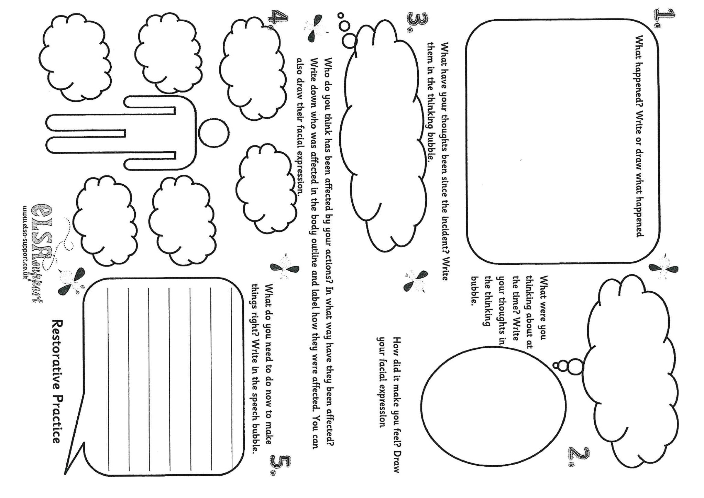**APPENDIX (4): RESTORATIVE PRACTICE INVESTIGATION SHEET SnaCM**

 **Appendix (5):**

**Scoil na Coróine Mhuire**

**Individual Behaviour Plan**

|  |  |  |  |  |
| --- | --- | --- | --- | --- |
| **Date of birth:**  **Date plan starts:** | | **Staff working with the pupil:**  **Date of next review:** | | |
| 1. **Challenging behaviour** | | 1. **Targets**   ***to manage this challenging behavior and a target date*** | | |
| 1. **Strategies for positive behaviour**   ***How we’re going to achieve these targets*** | | 1. **Early warning signs - The flashpoints**   ***Who?***  ***When?***  ***Where?***  ***What?***  ***Why?*** | | |
| 1. **Reactive strategies**   ***on recognising a flashpoint***  ***Immediate:***  ***Follow Up:*** | | 1. **Support after an incident**   ***Follow up support to close off an incident*** | | |
| **Agreement:**  Parent signature  Date | | Staff signature  Date | | |
| **Skills and Talents**  ***These 4 boxes are general as against anything to do with a particular incident*** | | | **Achievements** | |
| **Likes** | | | **Dislikes** | |
| **Log of potential incidents which needed to be managed: *Anytime a child feels they’ve had to implement management strategies it gets logged here and discussed – hopefully this is a reinforcement of some good actions/decisions taken*** | | | | |
| **Date** | **Description of behaviour** | | **Potential Trigger for incident** | **Action taken** |
|  |  | |  |  |
| **IBP evaluation and next steps: *A brief review of the current plan and developing it out*** | | | | |